DST P40I pressure transmitter for use in desalination systems, seawater cooling, and chemical processing
For use in corrosive environments, Danfoss offers the robust DST P40I pressure transmitter made of Titanium and with ceramic pressure sensing element. DST P40I is optimized for use in applications such as desalination systems, seawater cooling, and chemical processing. The transmitter housing is made from high-strength Titanium Grade 2, which is exceptionally resistant to a wide range of acids, alkalis, Sodium Chloride, and polluted water. The pressure sensing element is made from ceramic AI2O3 96% with superior chemical immunity. The pressure transmitter works following the piezo resistive principle, and the Wheatstone Bridge is printed directly on the inside of the ceramic diaphragm to ensure fast response time and a high degree of precision in measurements. DST P40I has been designed and tested to be highly resistant to continuous vibrations and cavitation in reverse osmosis desalination pump systems.
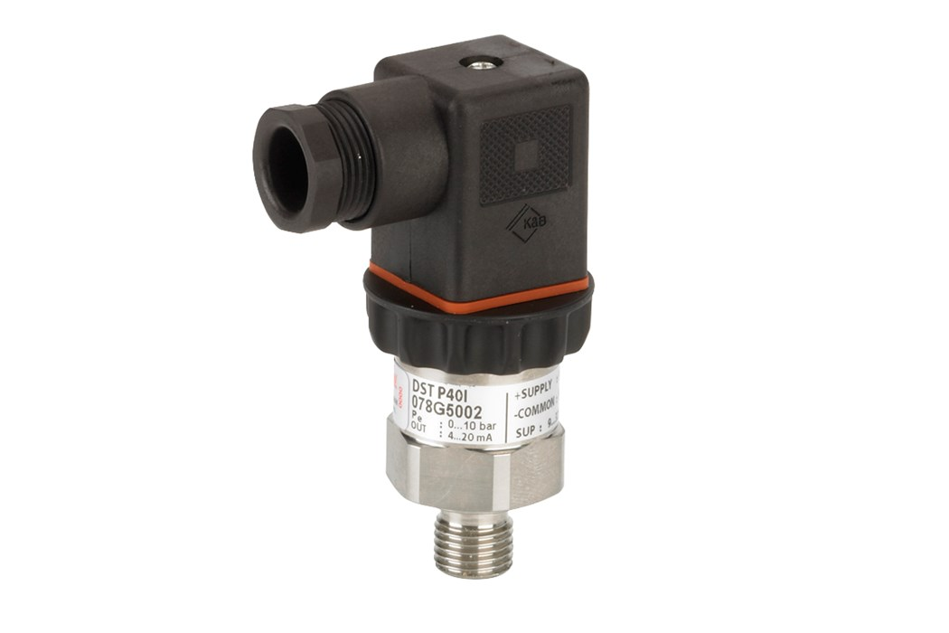

Features and benefits
High corrosion resistance, designed for use in harsh environments
Transmitter housing made of Titanium Grade 2
Ceramic sensing element made of AI2O3 96%
Pressure range 4-100 bar (standard)
Accuracy ± 1.5% FS (typical)
Temperature range 0-80°C
Output signal: 4 – 20 mA
Outstanding shock and vibration performance
Excellent EMC immunity, ensuring a failsafe measuring signal

Датчик давления для применений в морской воде и иных коррозионных средах.

